**Course: Algorithm**  
**Prof. Prem Nair**  
**Student: Binh Van Tran**  
**ID: 986648**  
**Homework: Lab 15**

1. **Question 1** Suppose Prob1, Prob2, and Prob3 are decision problems and Prob1 is polynomial reducible to Prob2, and Prob2 is polynomial reducible to Prob3. Explain why Prob1 must be polynomial reducible to Prob3

Since L1 *poly*🡪L2, any instance x for L1 can be converted in polynomial­ time p(n) into an instance *f(x)* for L2, such that x ∈ L1 if and only if *f(x)* ∈ L2, where n is the size of x. Likewise, since L2 *poly*🡪 L3, any instance y for L2 can be converted in polynomial-time q(m) into an instance g(y) for L3, such that y ∈ L2 if and only if g(y) ∈ L3, where m is the size of y. Combining these two constructions, any instance x for L1 can be converted in time q(k) into an instance g(f(x)) for L3, such that x ∈ L1 if and only if g(f(x)) ∈ L3, where k is the size of f(x). But, k ≤ p(n), since f(x) is constructed in p(n) steps. Thus, q(k) ≤ q(p(n)). Since the composition of two polynomials always results in another polynomial, this inequality implies that L1*poly*🡪L3

1. Illustrate the proof that the Hamiltonian Cycle problem is polynomial reducible to TSP

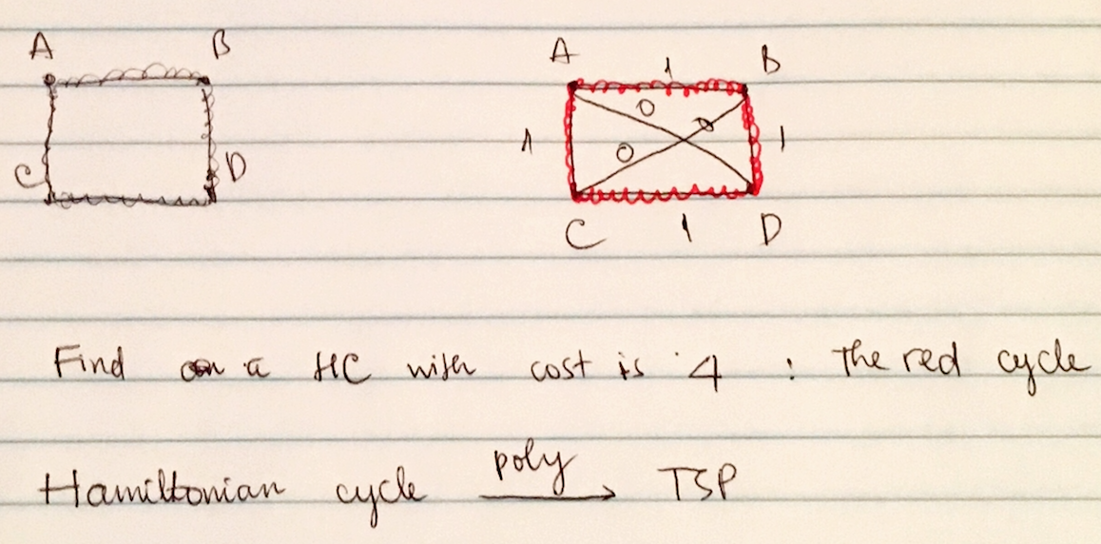

1. Show that TSP is NP – complete - Assume that HC problem is NP – complete

Given any NP – complete problem Q we have

Q is polynomial reducible to HC

HC is polynomial reducible to TSP

Therefore, Q *poly*🡪 TSP

TSP is in NP – complete